Maryam Ahmed Almanea

Mobile: +973 39907944, Residence: +973 13644198
Email: maryam_almanea@hotmail.com
Personal Details

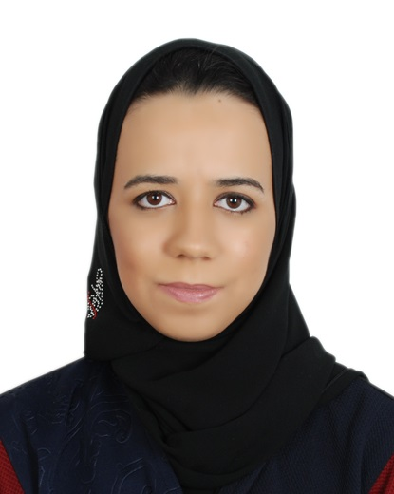
Nationality: Bahraini
Date of Birth: 18-Apri-1992
Place of Birth: Muharraq
Marital Status: Single
CPR Number: 920400272

Educational Qualification

2010-2015 University of Bahrain, B.Sc. in Computer Science. GPA - 3.06
2007-2010 Al Ahd Al Zaher Secondary Girls' School, Science.
Work Experience

September 2016 – Present :Ministry of Education
Teacher

- Teach design dynamic web pages course for secondary level.

September 2015 – August 2016 :White Palm Consultants
Developer

- Developed and designed native android mobile apps for Skiplino project.
- Localized the apps.
- Performed app testing before goes to live.
- Fixed bugs.

July 2014 – August 2014:Khaleji Commercial bank (KHCB)
Trainee

- Performed Benefit reconciliation settlement.
- Determined requirements and test case scenario for retail internet banking (RIB) project.
- Issued credit and debit cards.
- Registered customer for SMS banking.

Volunteer and Activities
- Member in Youth Technology Society (March2015 - present).
- University of Bahrain, Organizer in Uoblife 2 as the head of IT registration (April 2013).
- Organizer in Youth Tech symposium 2 (February 2013).
- University of Bahrain, Organizer in IT symposium 5 (November 2012).
- University of Bahrain, Organizer in Induction Day (September 2012).
- University of Bahrain , Organizer in Law symposium 4 (March 2012)
- University of Bahrain, Organizer in Uoblife 1 (April 2012).
- Member in College of IT Society (COITS) (2011-2014).
- Volunteer in Central Informatics Organization (August 2009).
Professional Certifications
Courses Attended

Courses Attended
C

- Oracle Database 12c Administrator Certified Associate, June 2017
Awards and Honors
Courses Attended

Courses Attended
C

- Best Five Senior Project Award, University of Bahrain. December 2014
Additional Skills

Technical Skills:

- Programming languages and Scripts: Hyper Text Markup Language (HTML), Cascading Style Sheet (CSS), Extensible Markup Language (XML), Hyper Preprocessor (PHP), Java, JavaScript, jQuery, JavaScript Object Notation (JSON), C++, C# , ASP.net and Visual Basic.net (VB).
- Database: Oracle 9g/12c SQL, PL/SQL, MySQL, Stored Procedure (SQL Server) and Android SQLite.
- Advanced Android Application Development.
- Android Wear Development.
- Web Development and Design UI / UX.
- Responsive Web Design using Bootstrap.
- Web Server: XAMPP and IIS.
- File Transfer Protocol (Fillezilla) and Web Hosting.
- Version Control System: Git and GitHub.
- Software : Android Studio IDE , Visual Studio , Oracle SQL Developer , Oracle Enterprise Manager 12c , Microsoft SQL Server Management Studio , Sublime Text , vMware Workstation and Cisco Packet Tracer .

- Design and Prototype Tools: SmartDraw, Balsamiq Mockups and Cacoo.
- Microsoft Office Programs and Adobe software (Photoshop, Sound booth and Premiere Pro).
- Operating Systems: Windows XP/7/8 and Mac OSX.

Interpersonal Skills:
- Independent but social, flexible challenging spirit.
- Good communication skills and high observation.
- Adapted and collaborator.
- Ability to work hard under pressure.
- Initiative with ability to handle multiple projects.
- Ability to work in a group environment.
- Eager to improve my knowledge and learn new skills.

Languages:
- Very good command of spoken and written Arabic, English.
Hobbies
Objectives

- Reading novels and books.
- Technology.
- Designing.
- Shopping.
- Volunteering.

- To obtain a challenging position in the field of Computer Science.
- To gain additional skills, obtain CISCO and Oracle certifications and high level of education involving in the master in Computer Science studies for the achievement of self-satisfaction and being a creative person in the society.
References

Available upon request.

